**MID TERM III EXAMINATION - 2024**

**PRIMARY TWO – MATHEMATICS**

NAME: ___________________________________

STREAM: _________________________________

**INSTRUCTIONS:**

1. Read well and answer all questions.

2. You must write well.

3. Write correct spellings and answer in full sentences where necessary.

**SECTION A**

1. **Add;** 2. **Complete**

Sh.50 1 week = ___days

Sh.20

1. Write the number shown on the abacus.

T O

1. Subtract; 5. Name the fraction below.

3 5 0 $\frac{1}{3}$

_____________

* 1 2 0

1. Multiply;

5 0

x 4

1. Fill in the correct numbers

679 = ____ hundreds ____ tens ____ones.

1. Write the number name.

139 ___________________________________________

1. Name the shape below.

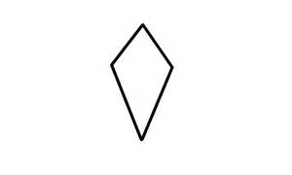___________

1. There are 5 fingers on one hand. How many fingers are there on three hands altogether?

1. Divide; $3\sqrt{9}$
2. Workout the numberline

**3+ 2 =**

…. 0 1 2 3 4 5 6 7 8 9 ….

1. Work out;

+ 3 = 5

1. Write the number after.

109, ______

1. Name the ninth month of the year.

__________________

1. Tell the time.

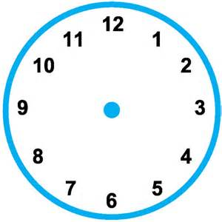

1. Write the place value of 4 in 641.
2. Find the number represented below.

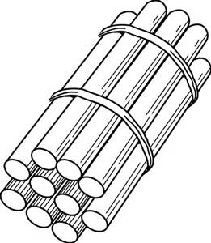+ 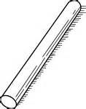=

1. What is the product of 2 and 3?
2. Joy

Jane

Who is lighter?

__________________________________________________

**SECTION B**

21.Study the pattern and write the missing number.

a) 20, 16, 12, _____

b) 12, 17, 22, _____

22. a) Write the first two months of the year.

i) ___________________

ii) __________________

b) If there are 12 months in one year. How many months are in 2years?

23.

|  |  |  |
| --- | --- | --- |
|  |  |  |

1. Write the unshaded fraction.
2. Name the shaded fraction.
3. Subtract;
$$\frac{7}{9} - \frac{5}{9} =$$

4. Compare and circle the bigger fraction.

24. Namukasa has 180 kilograms of beans and Mukasa has 215 kilograms

of beans.

1. Who has more kilograms of beans?
2. How many kilograms do the two people have altogether?

25. **Study the work on the numberline and fill in the missing**

**numbers.**

26. **Draw the shapes.**

|  |  |  |
| --- | --- | --- |
| square | Semi-circle | triangle |
|  |  |  |

27. **Work out;**

a) If a box has 8 pencils. How many pencils are in 3boxes?

b)Work out using repeated addition

4 x 3 = ____

_____ + ____ + ____ + ___ = ____

1. Naiga had 32 coloured pencils, 16 got lost. How many pencils remained?

28. a) Name the set below

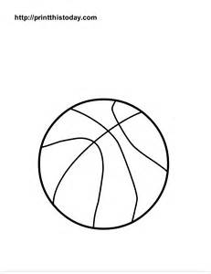

____________

b) How many members are in the above set?

c) Draw a set of pots.

29. Fill in the missing numbers

30 gate round about

dining hall

1. What is the distance from the gate to the round about?

1. Find the total distance from the gate to the round about and then to the dining hall.

31.Write in expanded form.

a) 756 =

b) 84 =

c) 309 =

32. The graph below shows the number of litres of water the girls

fetched from the well.

Names of girls

1. How many girls fetched water from the well?
2. How many litres of water did Jude fetch?
3. Who fetched the highest amount of water?
4. How many litres of water did Jane and Joan fetch altogether?

**END**